

Mathematics Specialist Year 11

Student name: _______________________Teacher name: ______________

Date: Friday 23rd July 2021

Task type: Response

Time allowed: 45 minutes

Number of questions: 6

Materials required: Calculator with CAS capability (to be provided by the student)

Standard items: Pens (blue/black preferred), pencils (including coloured), sharpener, correction fluid/tape, eraser, ruler, highlighters

Special items: Drawing instruments, templates, notes on two unfolded sheets of
A4 paper, and up to three calculators approved for use in the WACE examinations

Marks available: 40 marks

Task weighting: 10%

Formula sheet provided: Yes

Note: All part questions worth more than 2 marks require working to obtain full marks.

- [7 marks]
Use mathematical induction to prove that
$$3×5+6×6+9×7+…+3n\left(n+4\right)=\frac{n\left(n+1\right)\left(2n+13\right)}{2}$$
for all positive integers $n$.

- [2 marks]
A question in a Specialist exam paper asked students to prove the following statement:
‘$3n$ is odd if and only if $n$ is odd (where $n$ is an integer)’.
One student wrote the answer below. Explain clearly why they should not receive full marks for this answer.

Proof:
We prove the contrapositive. Assume that $n$ is an even integer. Then $n=2k$ for some integer $k$. Now
$$3n=3\left(2k\right) \\ =2\left(3k\right)$$

which is even since $3k$ is an integer. Hence if $n$ is even then $3n$ is even, which implies that $3n$ is odd if and only if $n$ is odd.

- [9 = 3+3+3 marks]
Write whether each of the following statements is true or false, and prove or disprove it accordingly.

- For all positive real numbers $x$
$$x^{3}-x≥x^{2}-x$$

- There exist distinct prime numbers $p$ and $q$ such that $p-q=2$.

- There exist distinct prime numbers$p$ and $q$ such that $p^{2}-q^{2}=2$.

- [6 marks]
Find the values of $x,y$ and $z$ in each of the following:
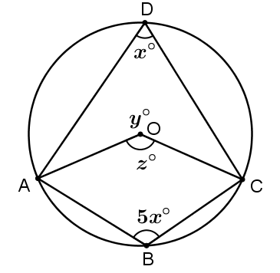
- $A, B, C$ and $D$ all lie on the circle with centre $O$:

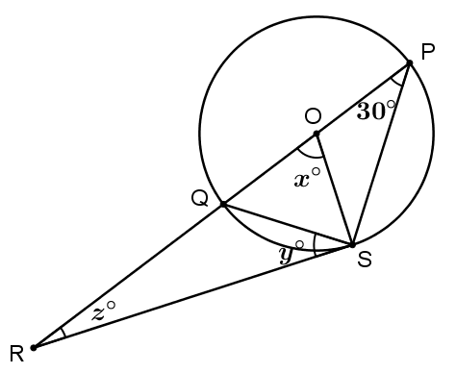
- $\overline{RS}$ is tangent to the circle with centre $O$.

- [5 marks]
$ABCD$ is a quadrilateral such that each of the four sides is tangent to the same circle, at the points $P,Q,R$ and $S$, as illustrated below. If $AB=15$, $BC=10$ and $CD=12$, find the length $AD$.
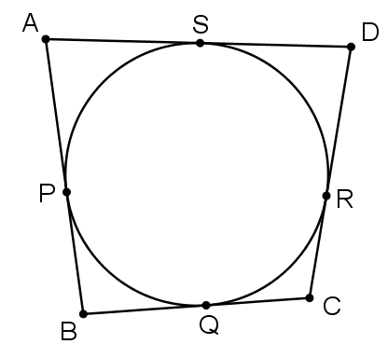

- [11 = 3+4+4 marks]
Solve each of the following trigonometric equations for $x$ in the stated domain.
Show all working to support your answers.
- $2\cos\left(x\right)=\sqrt{3}$ for $0≤x≤2π$

- $\sin\left(x+\frac{π}{4}\right)=-\frac{1}{\sqrt{2}}$ for $-π≤x≤π$

- $\frac{1}{\sqrt{3}}\tan{(5x)}=1$ for $0≤x≤π$

